**Project Design Phase-II**

**Data Flow Diagram & User Stories**

|  |  |
| --- | --- |
| Date | 1 November 2023 |
| Team ID | Team- 591756 |
| Project Name | ECOMMERCE SHIPPING PREDICTION USING MACHINE LEARNING |
| Maximum Marks | 4 Marks |

Data Flow Diagrams:

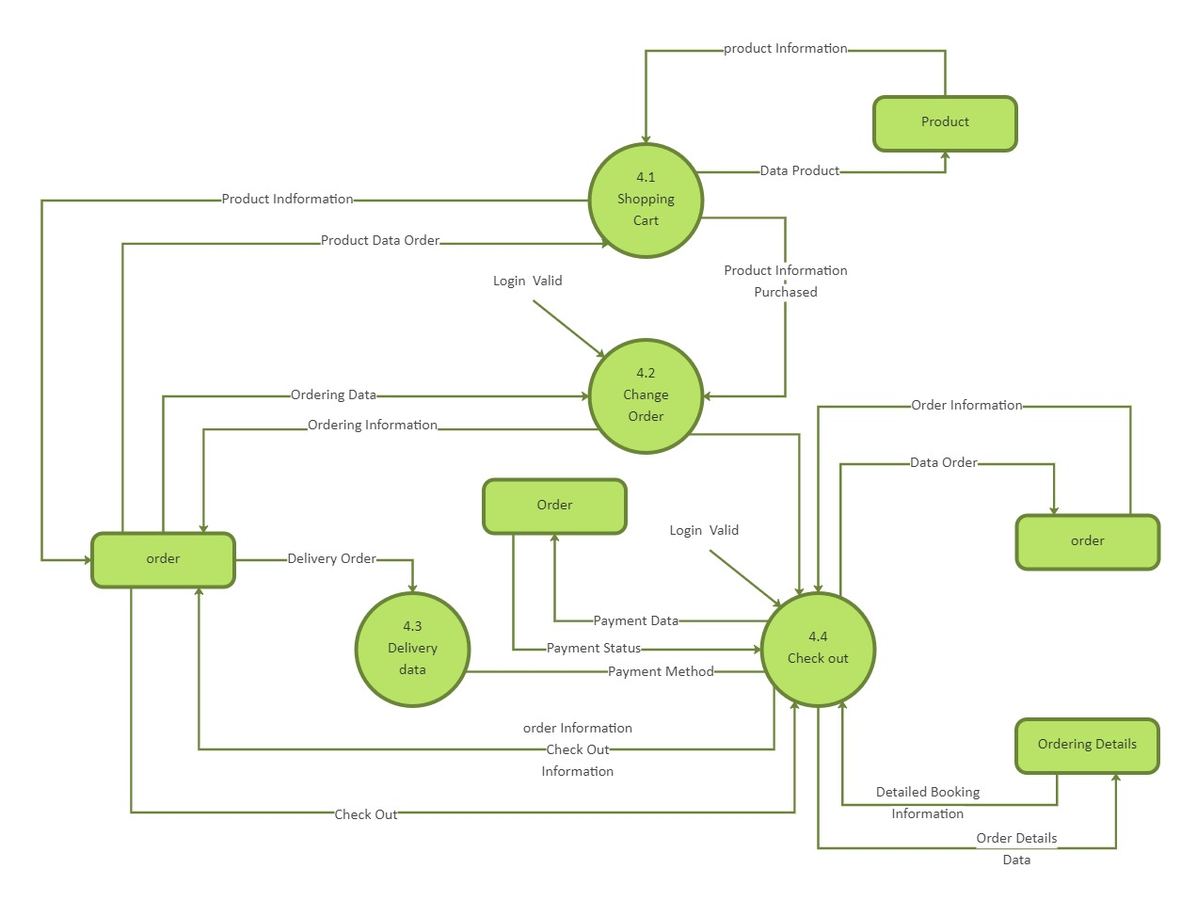

**User Stories**

|  |  |  |  |  |  |  |
| --- | --- | --- | --- | --- | --- | --- |
| **User Type** | **Functional Requirement (Epic)** | **User Story Number** | **User Story / Task** | **Acceptance criteria** | **Priority** | **Release** |
| Customer | Project  Shipping Time | USN-1 | AS a customer I want to knoe the estimated shipping time for my order | The system accurately predicts the shipping time based on the order details | High | Sprint-1 |
| Seller | Update shipping Information | USN-2 | AS a Seller I want to update the shipping information for a project | The system allows the update the shipping information and uses this information for future predictions | Medium | Sprint-2 |
| System Admin | Monitor Prediction Accuracy | USN-3 | AS a systemadmin I want to monitor the accurancy of the shipping time predictions | The system provides a dashboard showing the accuracy | Low | Sprint-3 |
| Customer | Track order | USN-4 | AS a Customer I want to track this status of my order | The system provides realtime updates on the status of the order | High | Sprint-2 |
| Seller | View sales statistics | USN-5 | As a seller I want to view statistics on my sales | The System provides a dashboard showing sales statistics | Medium | Sprint-4 |
| System Admin | Manage Uses | USN-6 | As a system admin I want to manage user accounts | The system allows the admin to add remove or modify user accounts | Low | Sprint-5 |

|  |  |  |  |  |  |  |
| --- | --- | --- | --- | --- | --- | --- |
| Customer | Provide FeedBack | USN-7 | As a customer I want to provide feedback on the shipping service. | The ystem allows the customer to provide feedback and uses this feedback to improve the prediction model | Medium | Sprint-4 |
| Seller | View feedback | USN-8 | As a seller I want to view customer feedback on the shipping service | The system provies a dashboard showing customer feedback | Low | Sprint-6 |